Name: _______________________
Class: __________
BÀI LUYỆN TẬP TIẾNG ANH KHỐI 2
Năm học 2019 - 2020
Lesson 9: Lunchtime!
I. Look and write the words:
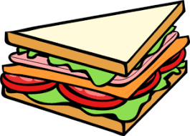  a. | _______________ __ |   e. | _________________
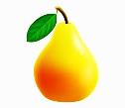  b. | _________________ |   f. | _________________
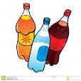  c. | _________________ |   g. | _________________
  d. | _________________ | 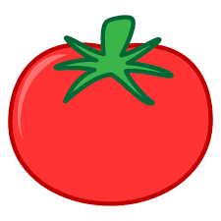  h. | _________________

II. Find and write food, fruit, drinks, and vegetables:
apple rice plum tomato bread milkshake
juice mango carrot soda chicken potato

VEGETABLES
____potato___
__________________
__________________

DRINKS
___soda___
______________
______________

FRUIT
___apple__
______________
______________

FOOD
___rice___
______________
______________

III. Complete the sentences:
a. It is a ______________. | 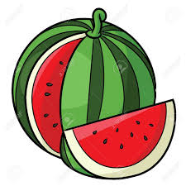
b. This is my ____________. | 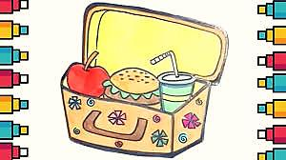
c. My favorite drink is _____________. | 
d. I like _____________. | 
Địa chỉ email cô Thủy (2/1, 2/2): wushimizu@gmail.com
Địa chỉ email cô Thơ (2/3, 2/4): phantho8315@gmail.com
Good luck to you!

